# ABC’s Inventory Management System

## Add Staff Test Script

|  |  |  |  |  |  |
| --- | --- | --- | --- | --- | --- |
| **Test Name** | | Test Add Staff (AS001) | | | |
| **Use Case Tested** | | Manage Staff | | | |
| **Test Description** | | This test tests if the system can add a new staff who can access the system. | | | |
| **Pre-Conditions** | | Users need be logged in as a Warehouse Staff (Warehouse Staff Access) and in the Manage Staff page  Meta data to store Staff details in the database must exist. | | | |
| **Post-Conditions** | | A new Staff is added to the system. | | | |
| **Result (Pass/Fail/Warning/ Incomplete)** | | Pass | | | |
|  | **Test Step** | | **Expected Test Results** | **P** | **F** |
| 1. | Click on ‘Add Staff’ icon at ‘Manage Staff’ | | System prompts user to enter new staff details. | P |  |
| 2. | Enter all required data. (For some data sets a few details will be deliberately not entered to check how the system reacts to such scenario.) | | System waits for user to click on the ‘Add Staff (Tick)’ icon or ‘Clear Text’ icon | P |  |
| 3. | Click on ‘Clear Text’ icon | | System clears all information entered in each field. | P |  |
| 4. | Repeat Step 2 and click on ‘Add Staff’ icon. | | 4.1. If all necessary fields are not entered, system displays an error message asking users to enter all required fields which will be highlighted in red. | P |  |
|  |  | | 4.2. If Username entered already exists, system displays an appropriate message and prompts user to enter a unique username. | P |  |
|  |  | | 4.3. If password and confirm password field do not match, system displays an error message asking users to reenter the password. | P |  |
|  |  | | 4.4. If all necessary fields are entered, the system adds the staff details to the database, displays an appropriate message and displays the ‘Manage Staff’ Page. | P |  |

## Data Set 1

|  |  |
| --- | --- |
| **Data Set 1 (Normal Flow)** | |
| **Fields** | **Values** |
| **First Name** | Ron |
| **Last Name** | A |
| **Email Address** | rona@email.com |
| **Phone** | 123456 |
| **Address** | 23 Ron Street, Ron, NSW 1000 |
| **Date of Birth** | 21/07/1989 |
| **Username** | ron |
| **Password** | ron |
| **Confirm Password** | ron |
| **Base Location** | Newtown Warehouse |

**Step 1**

After clicking on ‘Add Staff’ Icon at ‘Manage Staff’ system prompts user to enter new staff details

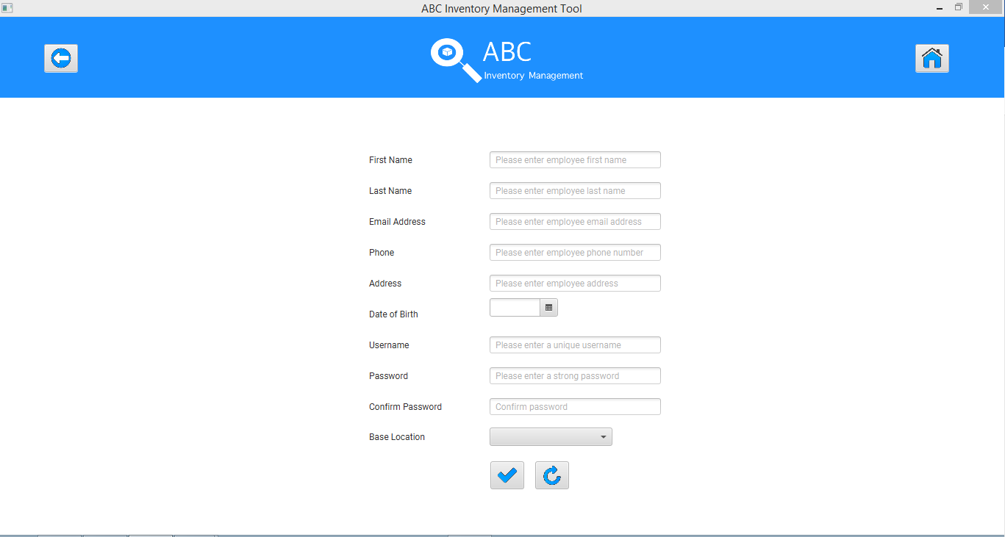

**Step 2**

User enters all required data.

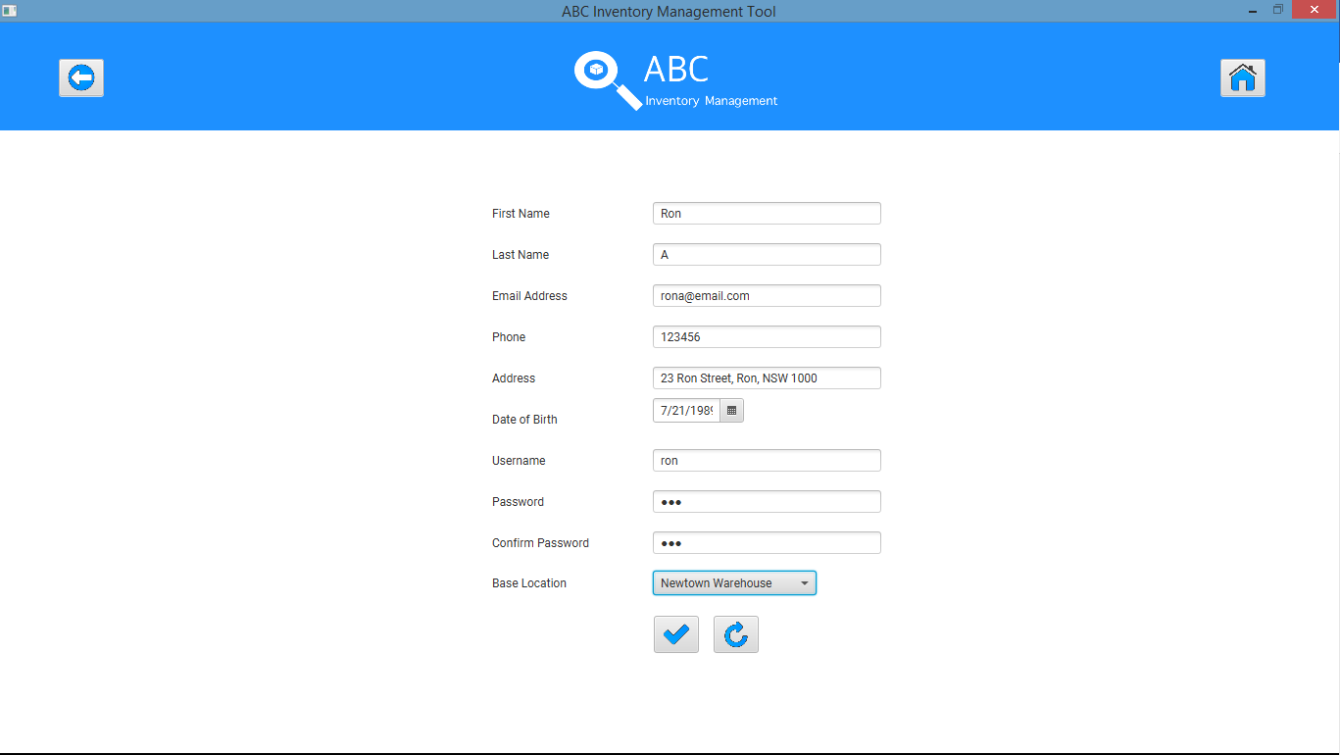

**Step 3**

Click on the ‘Clear Text’ icon after which system clears all data entered

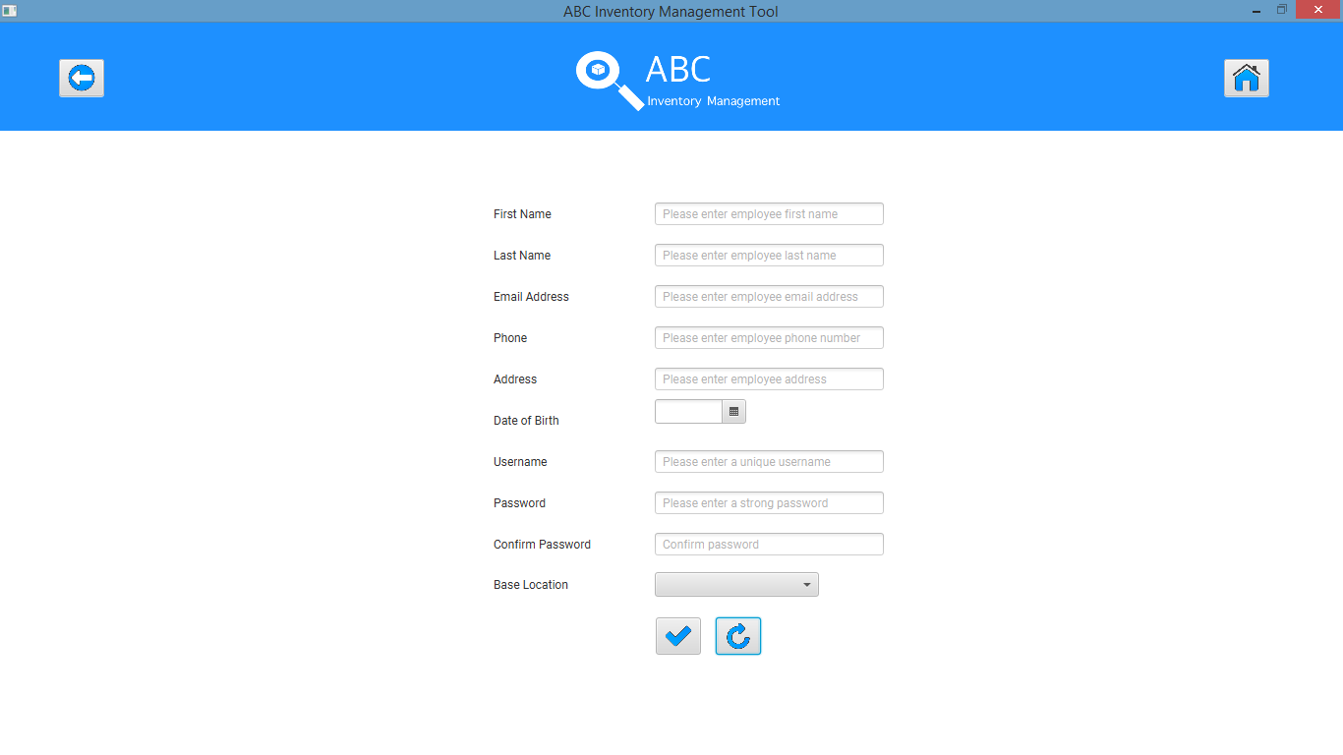

**Step 4 (4.4)**

Re enter all required data and click on ‘Add Staff’ Icon

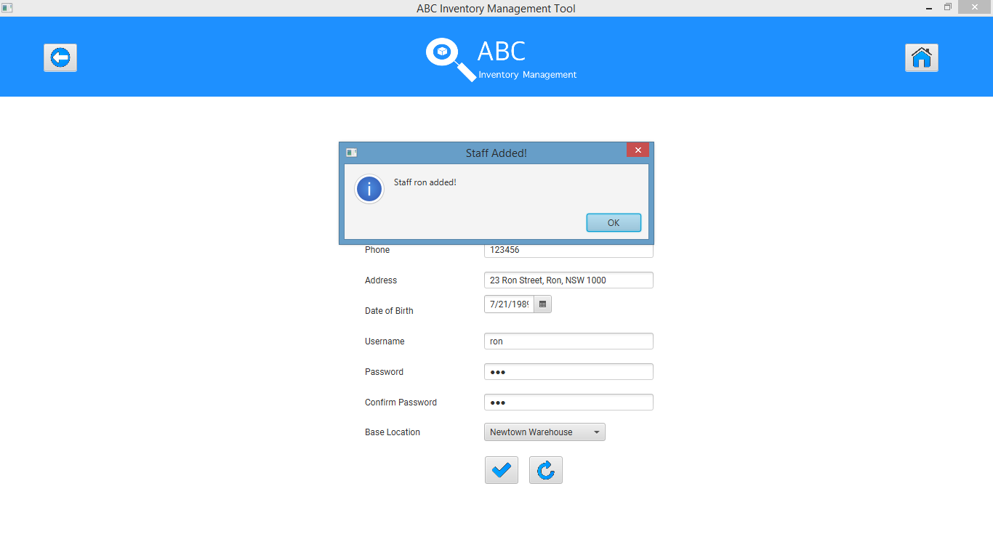

System displays ‘Manage Staff’ with the newly added staff having username ‘ron’

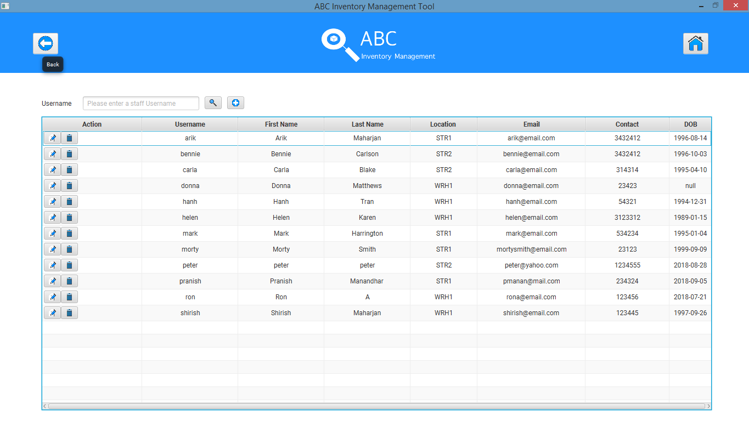

## Data Set 2

|  |  |
| --- | --- |
| **Data Set 2 (Enter username that already exists)** | |
| **Fields** | **Values** |
| **First Name** | Ronnie |
| **Last Name** | B |
| **Email Address** | ronnieb@email.com |
| **Phone** | 123457 |
| **Address** | 23 Ronnie Street, Ronnie, NSW 2001 |
| **Date of Birth** | 31/08/1995 |
| **Username** | ron |
| **Password** | ronnie |
| **Confirm Password** | ronnie |
| **Base Location** | Epping Store |

**Step 1**

After clicking on ‘Add Staff’ Icon at ‘Manage Staff’ system prompts user to enter new staff details



**Step 2**

Enter all required data. Set username as ron which already exists.

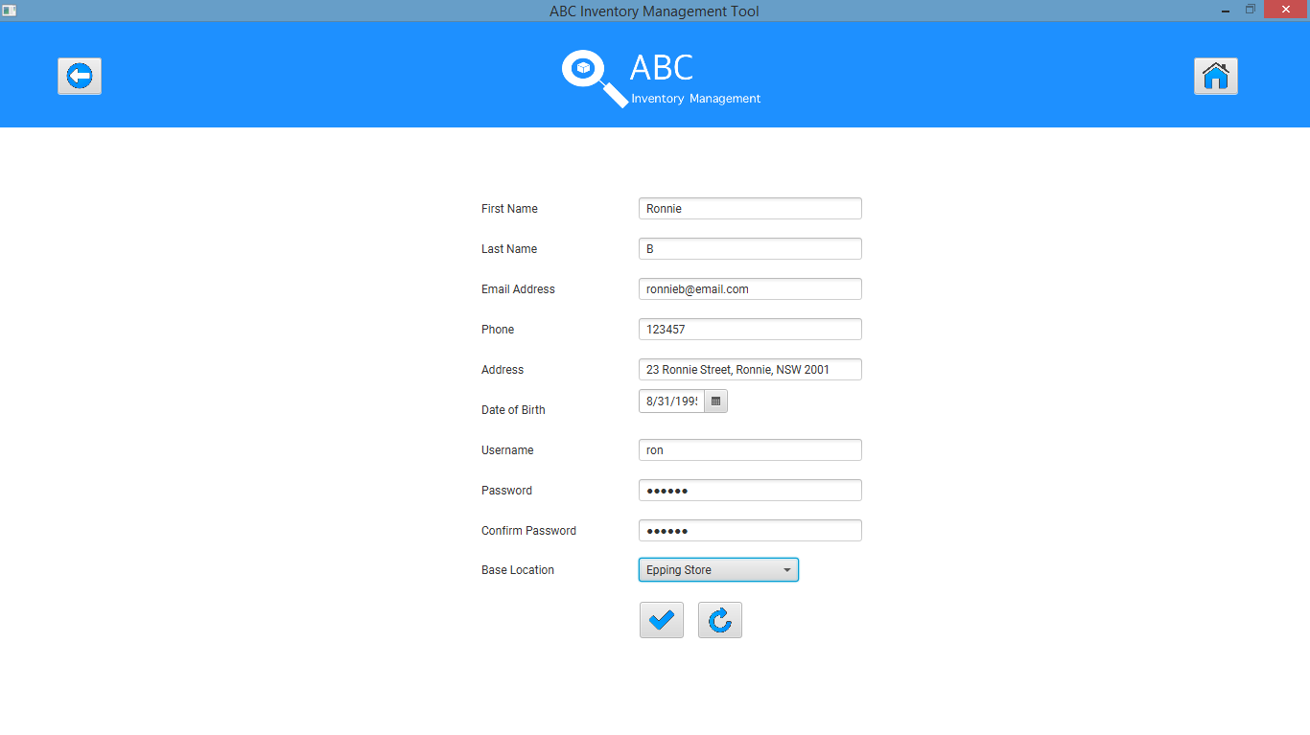

**Step 3**

Click on ‘Clear Text’ icon which clears all fields.



**Step 4 (4.2)**

Repeat step 2 and click on ‘Add Staff’ icon after which the system displays an appropriate message as shown in the screenshot below.

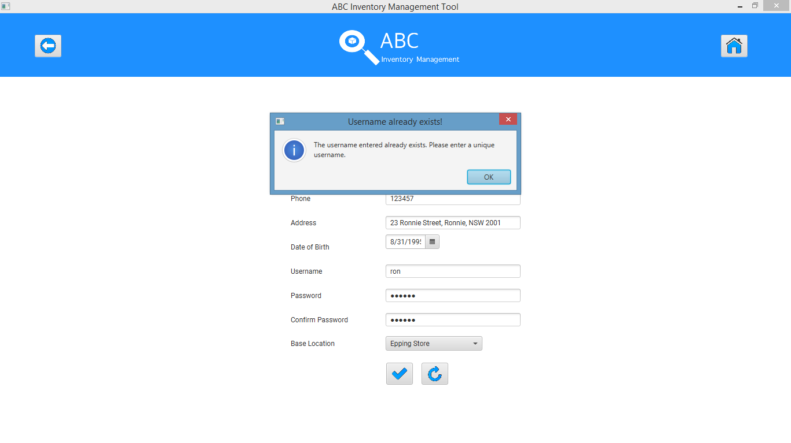

The username field is cleared for user to re enter a unique username.

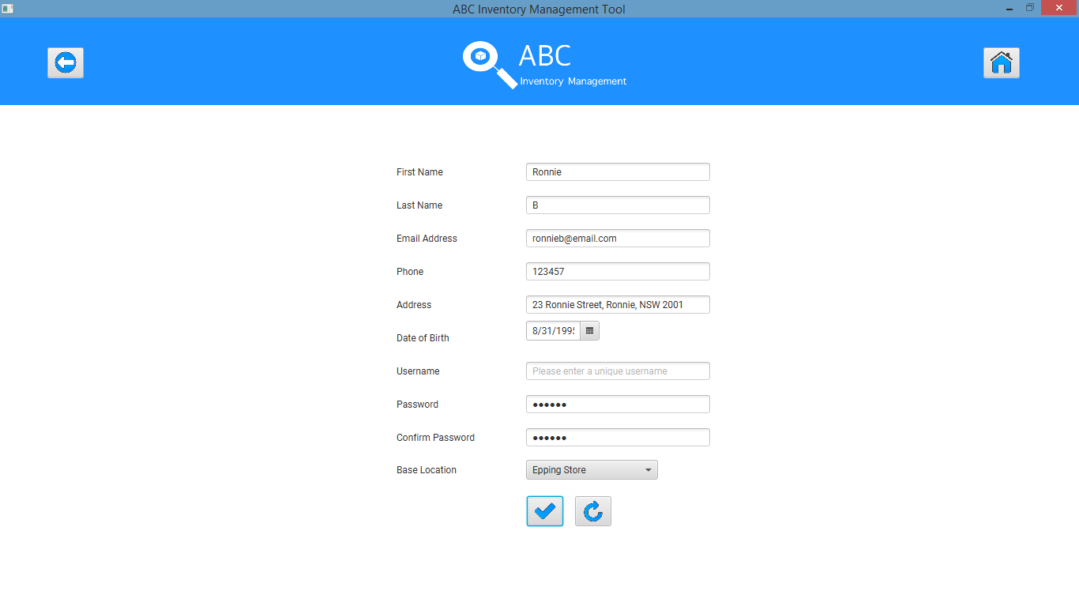

## Data Set 3

|  |  |
| --- | --- |
| **Data Set 3 (Incomplete Fields)** | |
| **Fields** | **Values** |
| **First Name** | Derek |
| **Last Name** | A |
| **Email Address** | (empty) |
| **Phone** | 1234576 |
| **Address** | 23 Derek Street, Derek, NSW 2002 |
| **Date of Birth** | 02/12/1991 |
| **Username** | (empty) |
| **Password** | derek |
| **Confirm Password** | (empty) |
| **Base Location** | Oxford Store |

**Step 1**

After clicking on ‘Add Staff’ Icon at ‘Manage Staff’ system prompts user to enter new staff details



**Step 2**

Enter all fields except email address, username and confirm password field.

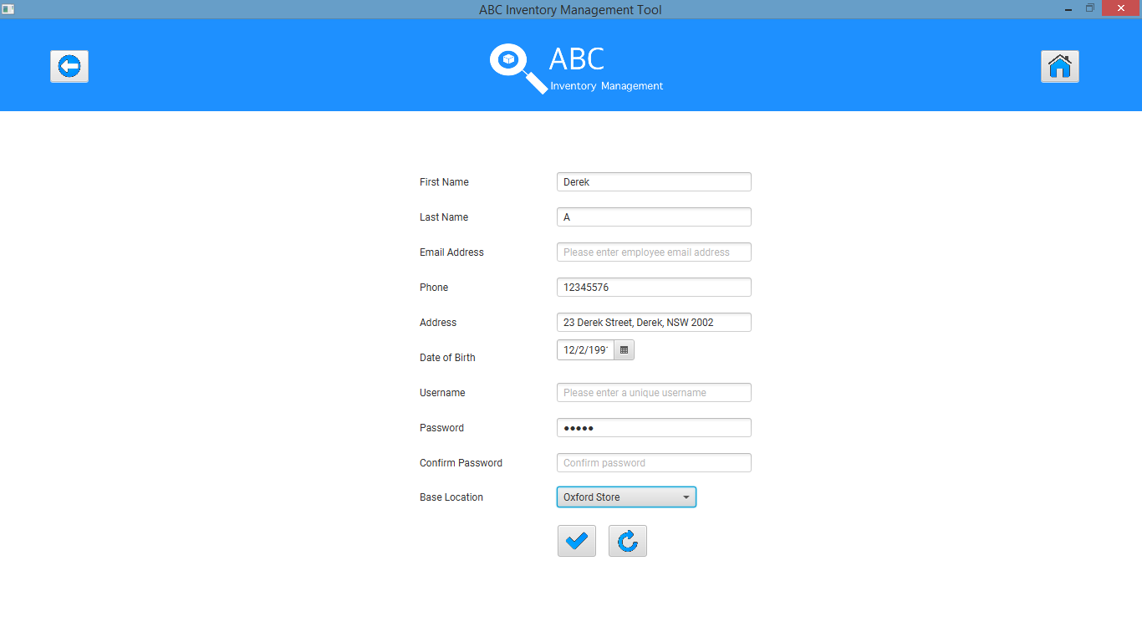

**Step 3**

Click on ‘Clear Text’ icon which clears all fields.



**Step 4 (4.1)**

Repeat step 2 and click on ‘Add Staff’ icon after which the system displays an appropriate message as shown in the screenshot below.

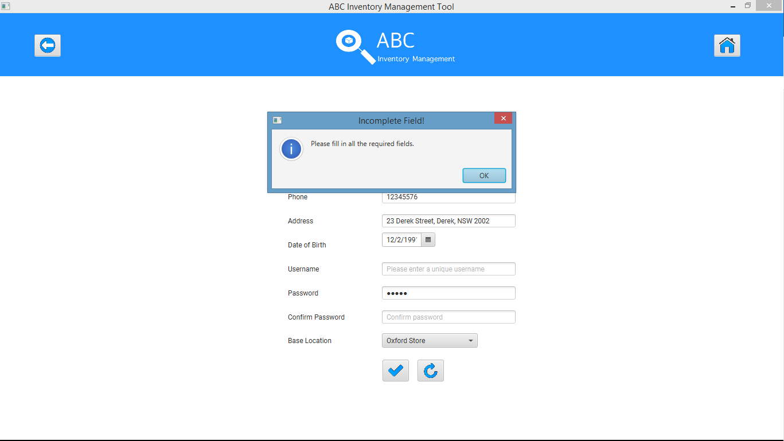

System highlights and prompts user to fill necessary fields.

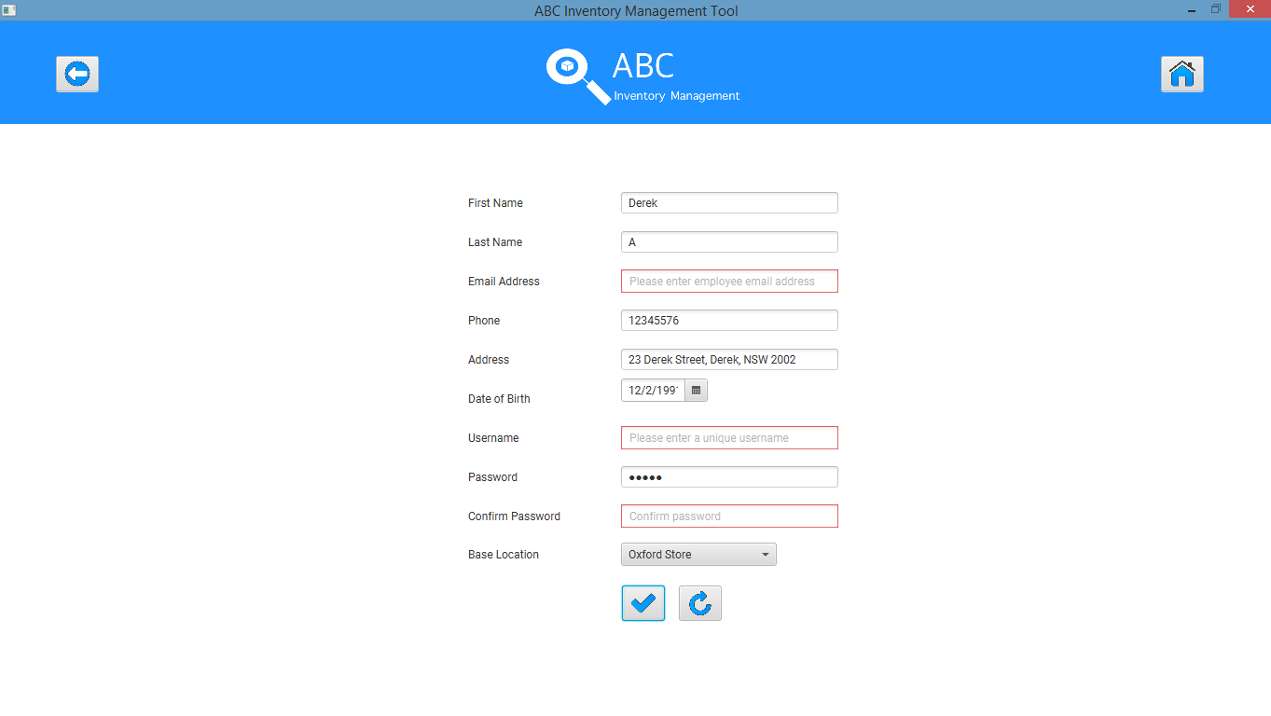

## Data Set 4

|  |  |
| --- | --- |
| **Data Set 4 (Unmatched password fields)** | |
| **Fields** | **Values** |
| **First Name** | Bailey |
| **Last Name** | A |
| **Email Address** | bailey@email.com |
| **Phone** | 654321 |
| **Address** | 21, Bailey Street, Bails, NSW 2003 |
| **Date of Birth** | 08/10/1979 |
| **Username** | bailey |
| **Password** | bailey |
| **Confirm Password** | bailei |
| **Base Location** | Newtown Warehouse |

**Step 1**

After clicking on ‘Add Staff’ Icon at ‘Manage Staff’ system prompts user to enter new staff details



**Step 2**

Enter all required values but enter different values for password and confirm password fields.

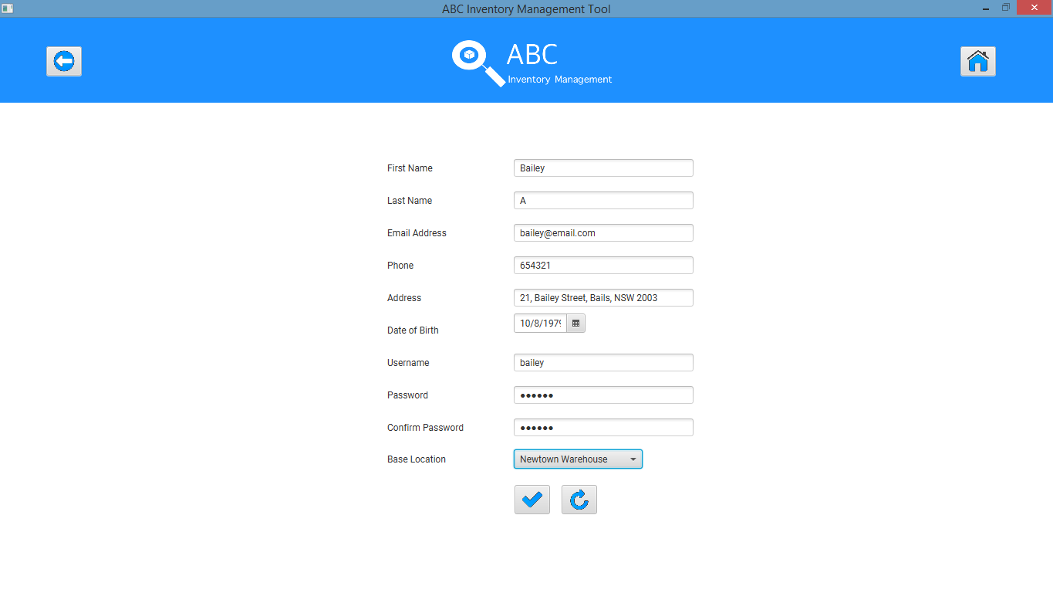

**Step 3**

Click on ‘Clear Text’ icon which clears all fields.



**Step 4 (4.3)**

Repeat step 2 and click on ‘Add Staff’ icon after which the system displays an appropriate message.

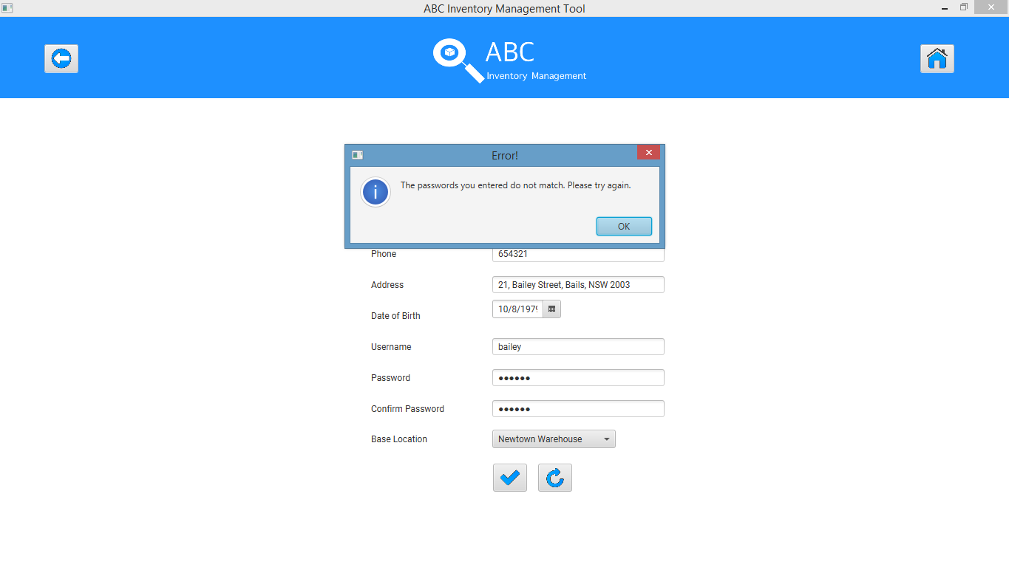

The system highlights and clears the password and confirm password fields and prompts the user to fill those fields.